Dr. Perez’s Cooperative Classroom

Individual Roles & Responsibilities

(although everyone participates some have additional duties.)

|  |  |  |
| --- | --- | --- |
| **Roles** | **Responsibilities** | This Week’s Team Member Assignments (1-4) |
|   **Leader** | **Does…**   * Helps everyone work. * Invites everyone to participate. * Checks that everyone understand the directions.   **“Says” …**   * Let’s read the directions. * Let’s go onto the next step. * What do you think? * Do you understand? |  |
| A picture containing object  Description automatically generated  Materials Manager | **Does…**   * Passes out and collects all materials. * Makes sure materials are being treated with respect.   **“Says” …**   * Are you finished? * Can I put back all the materials? * Let’s clean up. |  |
| **Recorder/Reporter**   | **Does…**   * Takes discussion notes. * Asks questions.   **“Says” …**   * **What do you mean when you say…?** * **So far, we talked about…** |  |
| Timekeeper | **Does…**   * **Helps the team keep to the time limits.** * **Helps the team to reach conclusions.**   **“Says” …**   * **We have # minutes left.** * **Let’s try to wrap this up.** |  |

VOICE LEVELS

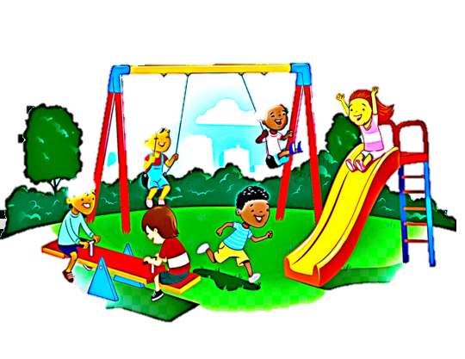

**Dr. Perez’s**

**Hand goes up;**

**We all**

**Quiet down!**

Dr. Perez’s Classroom

Whisper

– Pair/Share

Cooperative

Group Work

Loud & Proud

SPEAKER

Outdoor –

playground

SILENCE PLEASE!

**0**

**1**

**2**

3

**4**